Links: <https://github.com/TayRenYuan/RenYuan_PESS_Project>

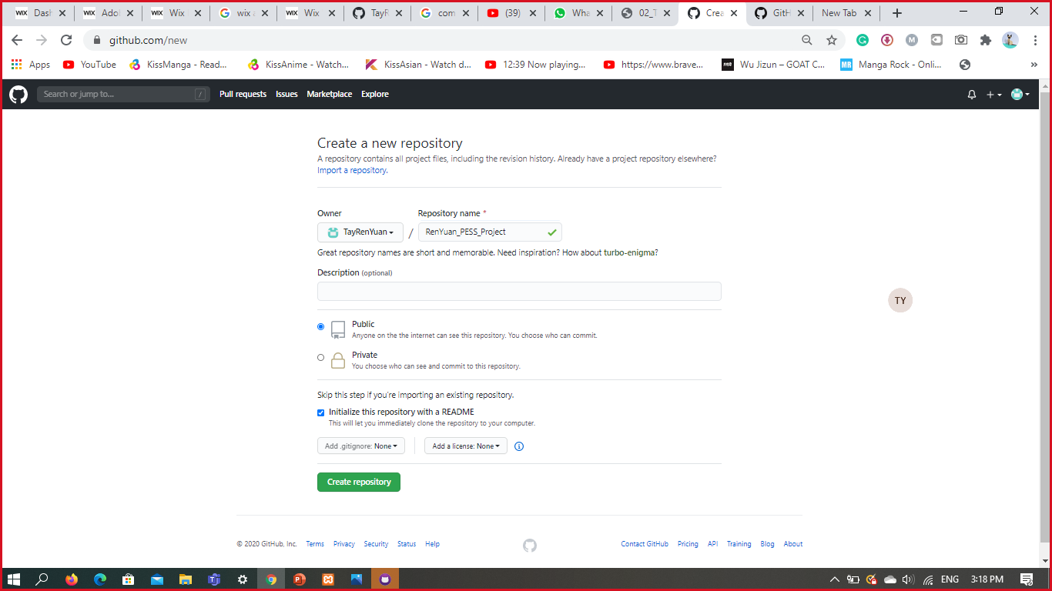**Create a new repository**

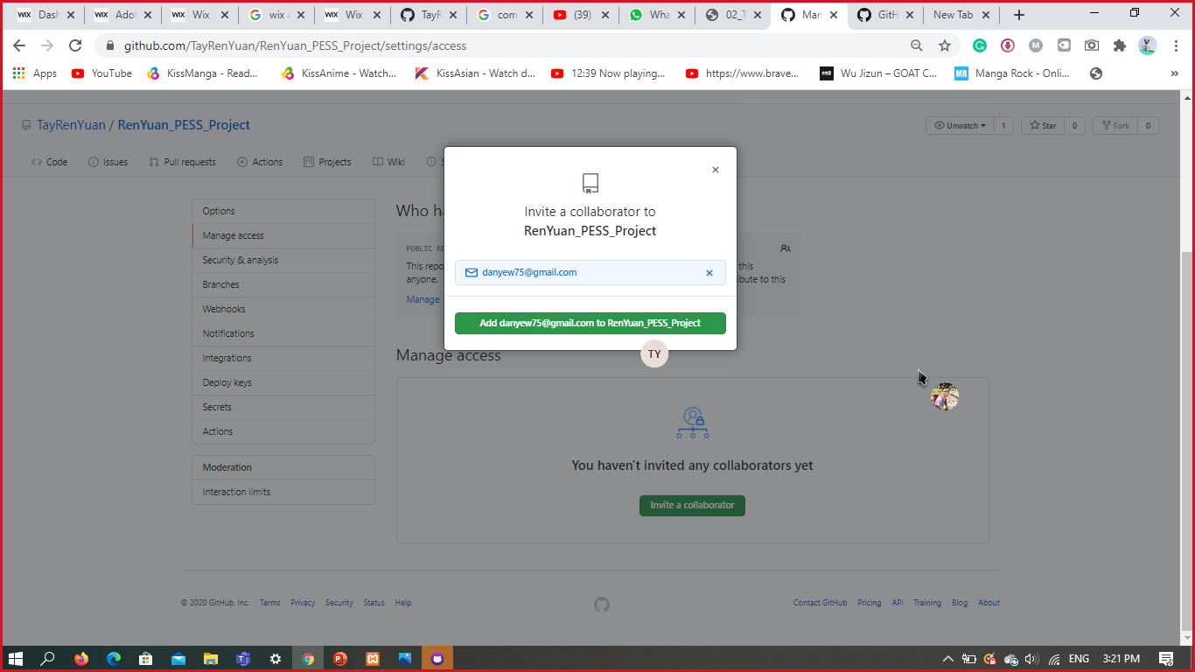**Invite a collaborator**

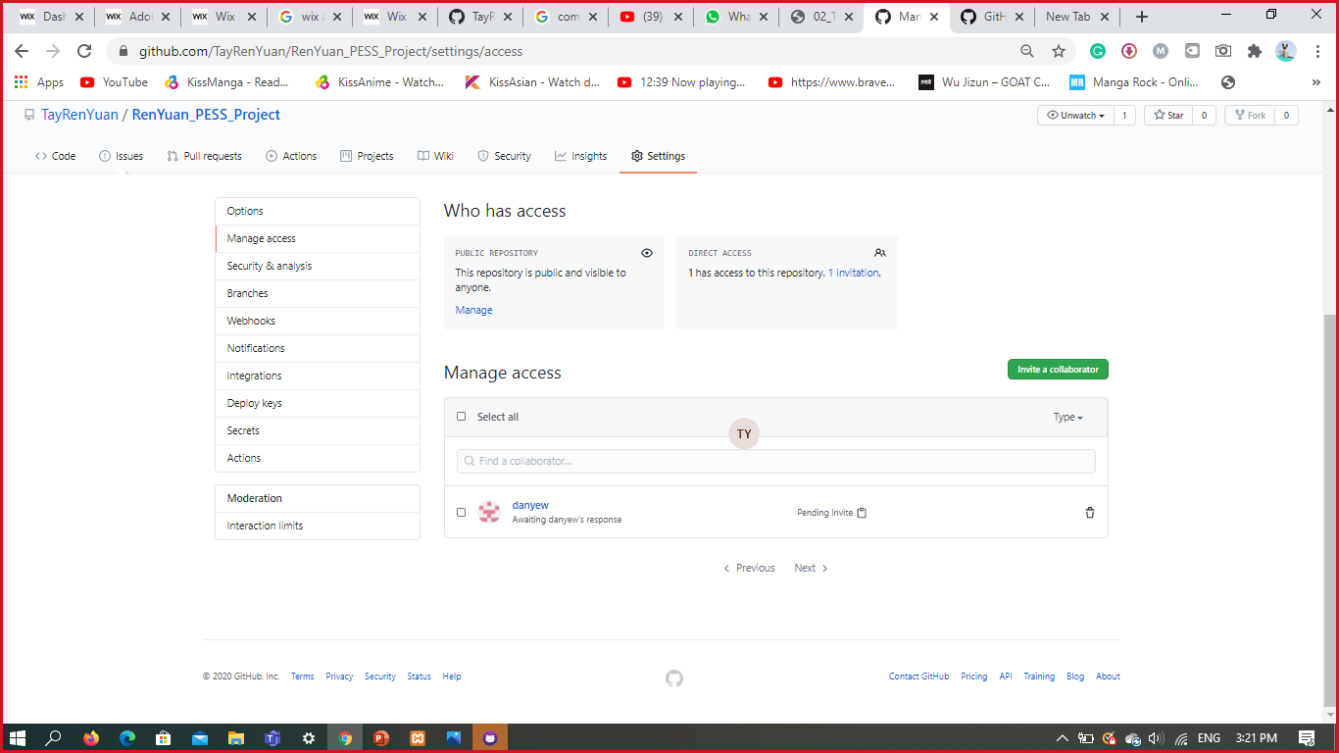

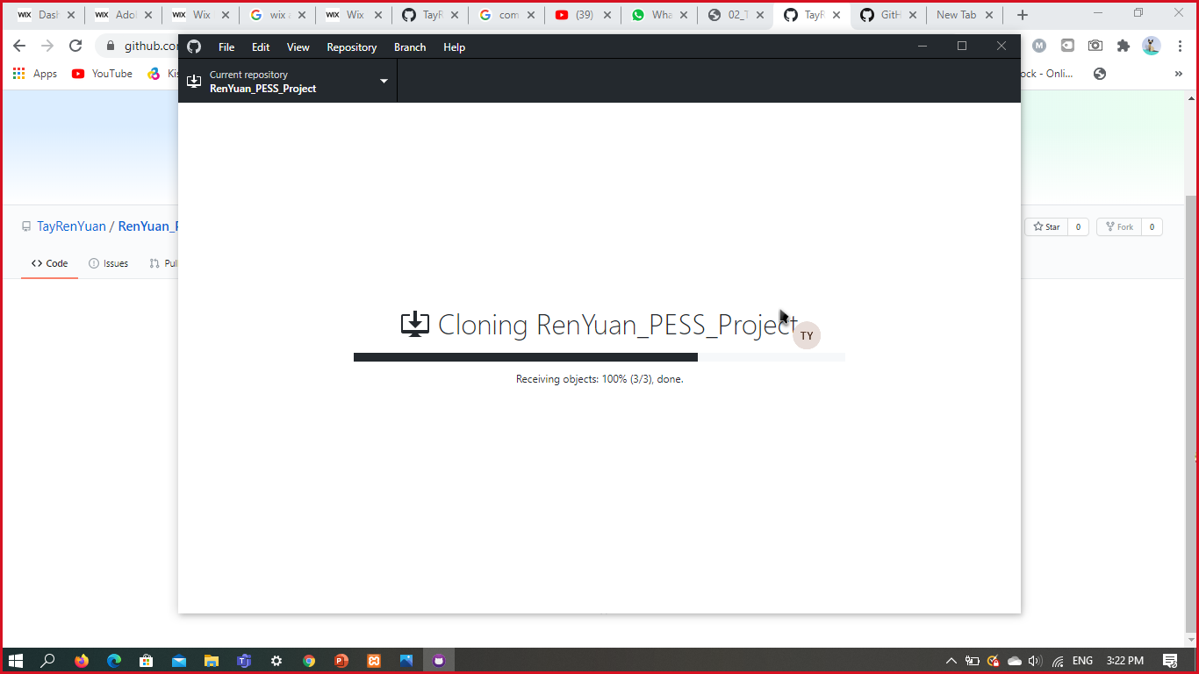**Click Clone or Download. Then Clone it to a repository and choose the local path:**

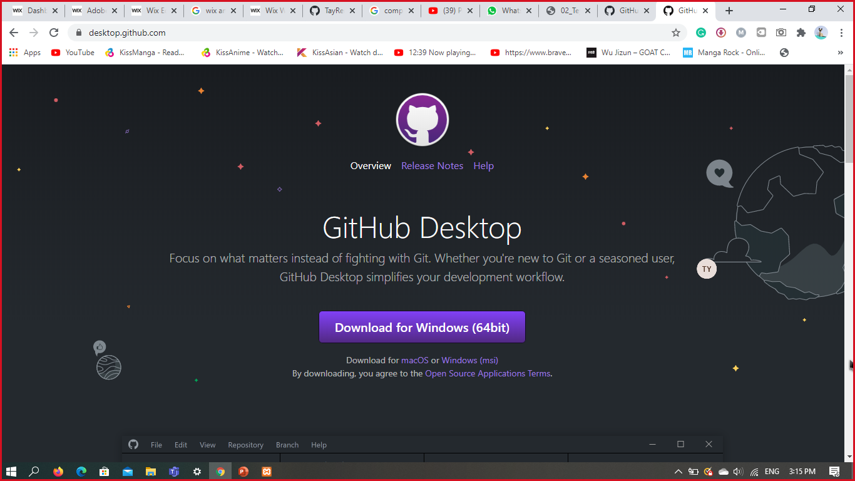**Download GitHub Desktop**

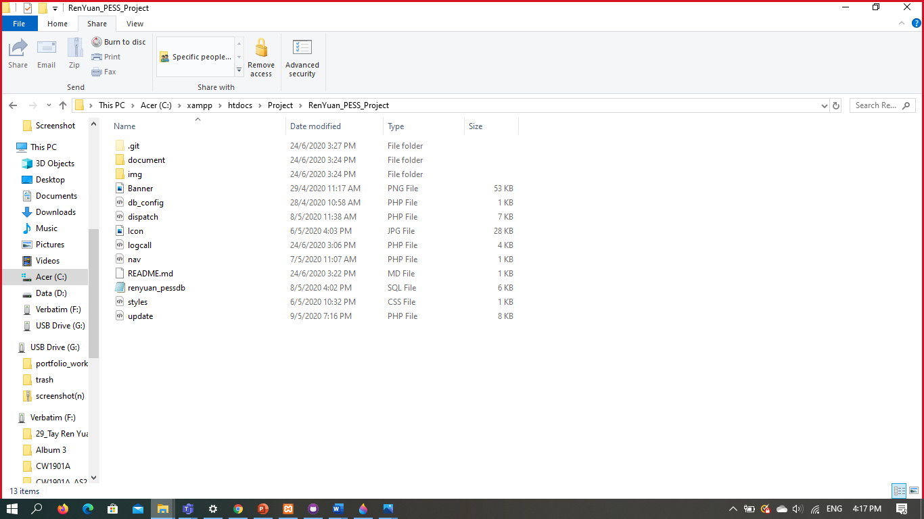**A file name (README.md) is added in your local folder**

**Open your Github.exe**

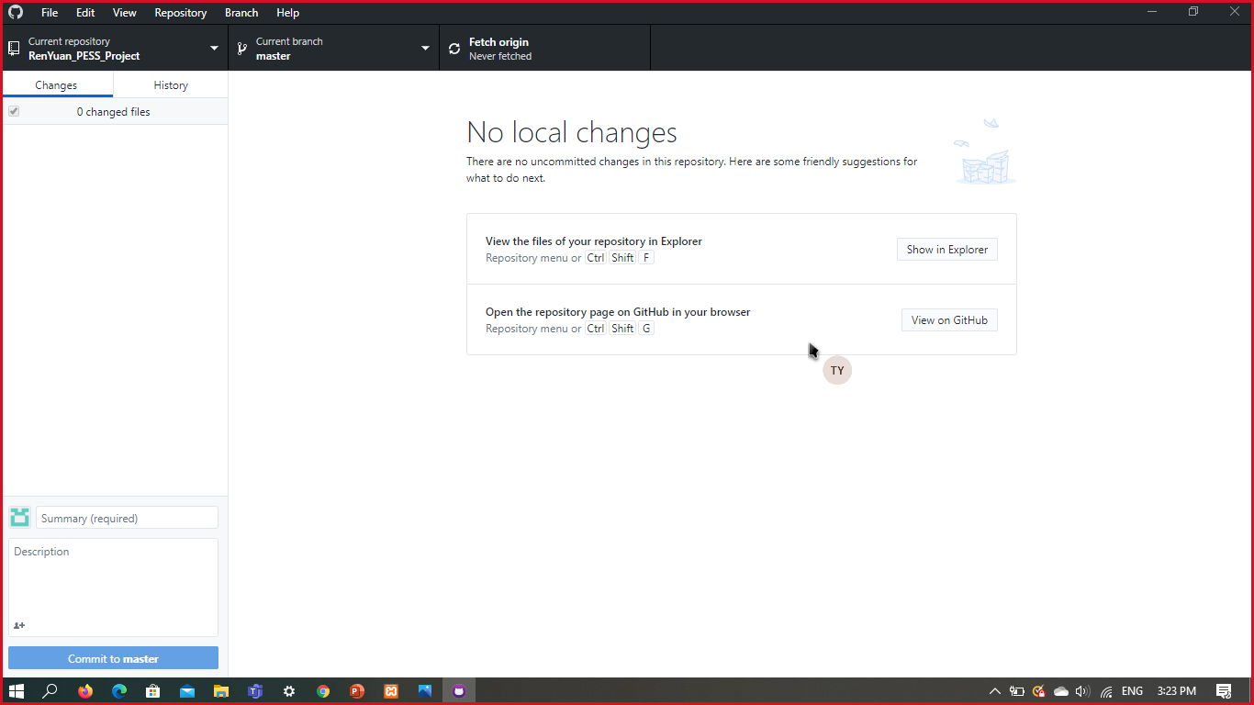

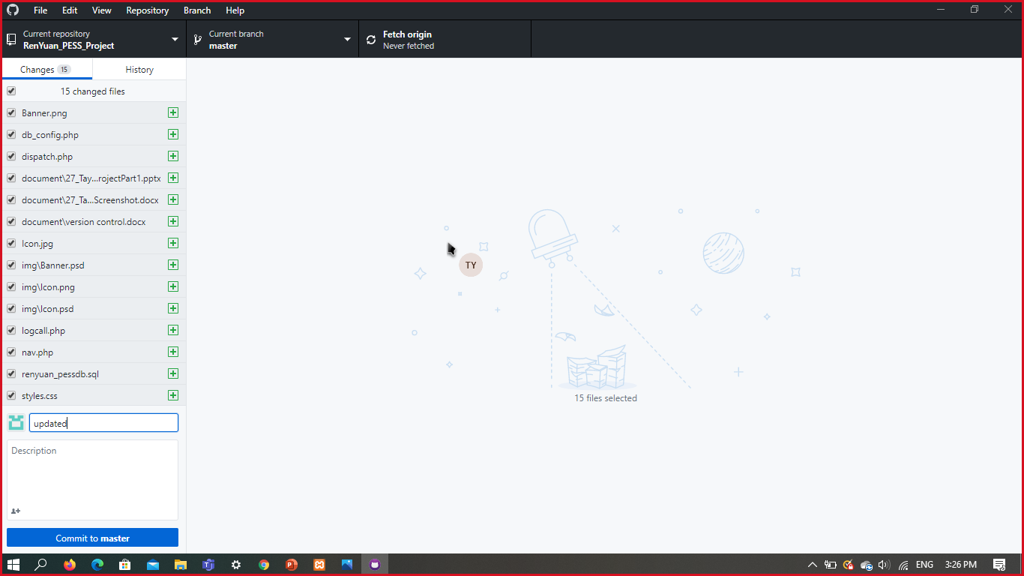**Click commit to master after you did changes**

**Click “Push Origin”**

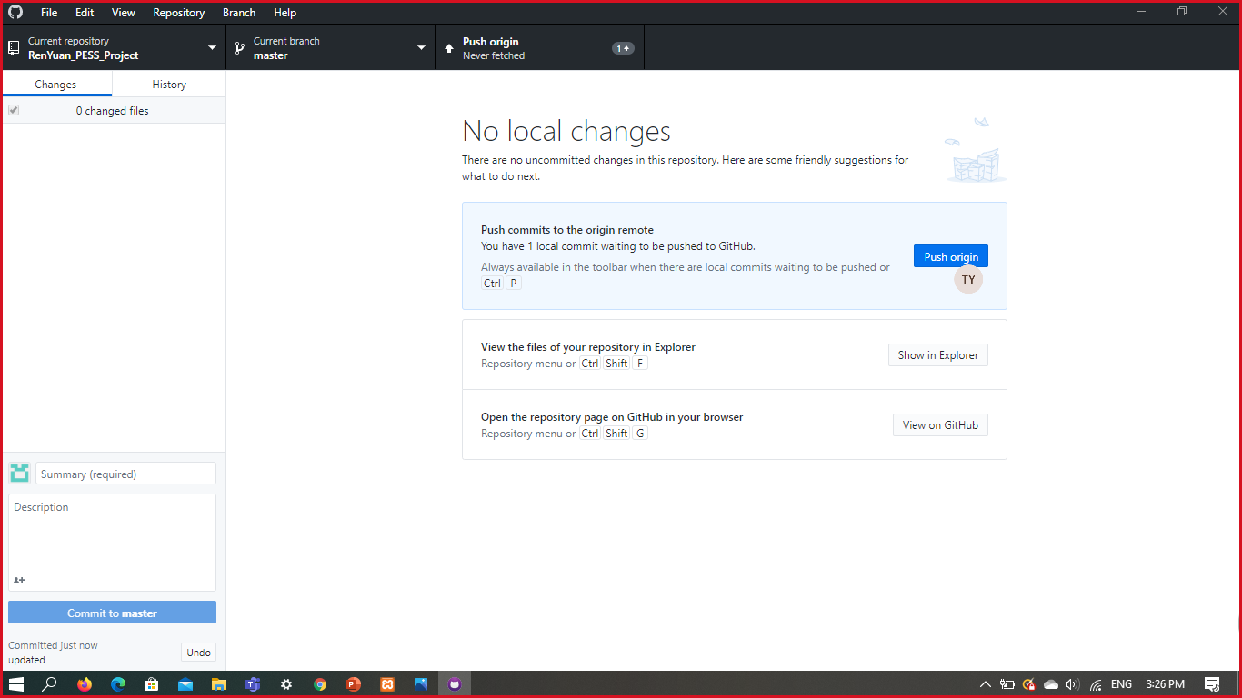

**Check your web repository(RenYuan_PESS_Project) for any changes**